Intensity measures to consider for implementation on CyberShake:

- Arias intensity, I_{A}:
  - Equation (1) in reference [1]

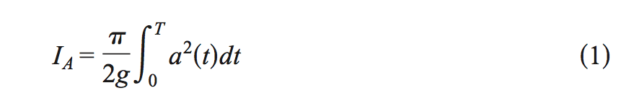

- Energy integral, I_{E}:
  - Equation (2) in reference [1]

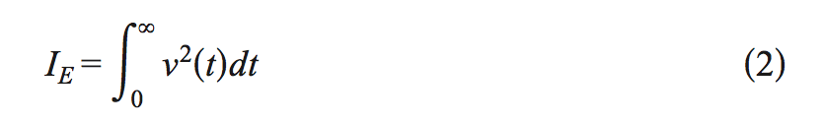

- Cumulative absolute velocity, CAV:
  - Equation (2) in reference [2]

- Significant durations:
  - Calculated form I_{A}: Da5-75%, Da5-95%, Da20-80%
  - Calculated from I_{E}: Dv5-75%, Dv5-95%, Dv20-80%
  - Significant durations are defined as the time interval over which the specified amount of energy is dissipated (e.g. figure 2 in [1])

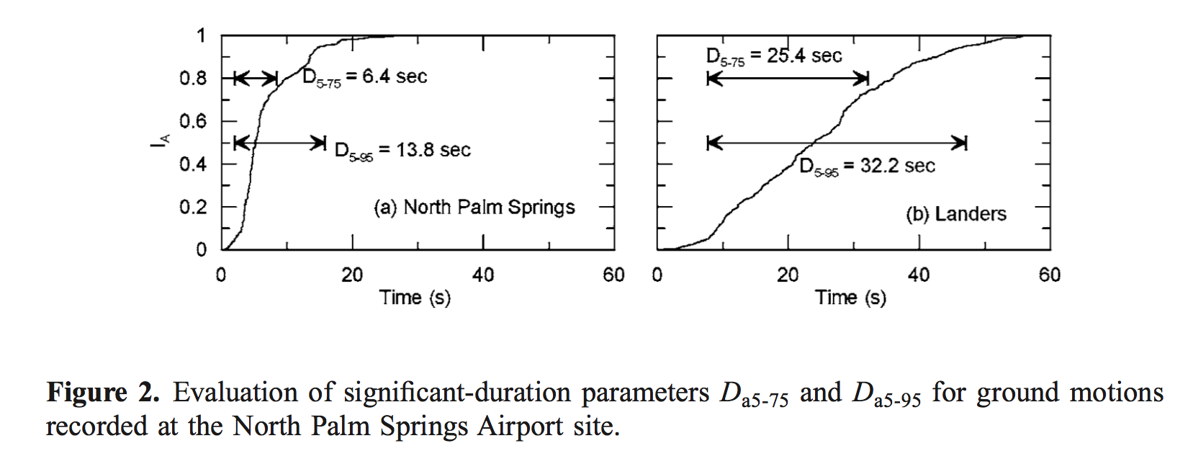

Suggested implementation of:

- Significant durations for each component of simulated seismograms: Da5-75%, Da5-95%, Dv5-75%, Dv5-95%
- Since I_{A} and I_{E} are calculated in order to compute significant durations, they could also be stored
- Calculate the values for both hybrid-broadband as well as deterministic seismograms
- I_{A} and D_{a} metrics are planned to be implemented on the SCEC BBP (as part of the validation gauntlet), so perhaps this can be coordinated with Fabio

The suggested metrics seem to be used very frequently. If additional space in the sql database is not too restrictive, the values of CAV, Da20-80% and Dv20-80% could also be included.

References:

[1] Kempton, Justin J., and Jonathan P. Stewart. “Prediction Equations for Significant Duration of Earthquake Ground Motions Considering Site and Near-Source Effects.” Earthquake Spectra 22, no. 4 (November 1, 2006): 985–1013. doi:10.1193/1.2358175.
[2] Barbosa, AR, Ribeiro, FLA, Neves, LC. Effects of Ground-motion Duration on the Response of a 9-Story Steel Frame Building. Proceedings of the 10th National Conference in Earthquake Engineering, Earthquake Engineering Research Institute, Anchorage, AK, 2014.

